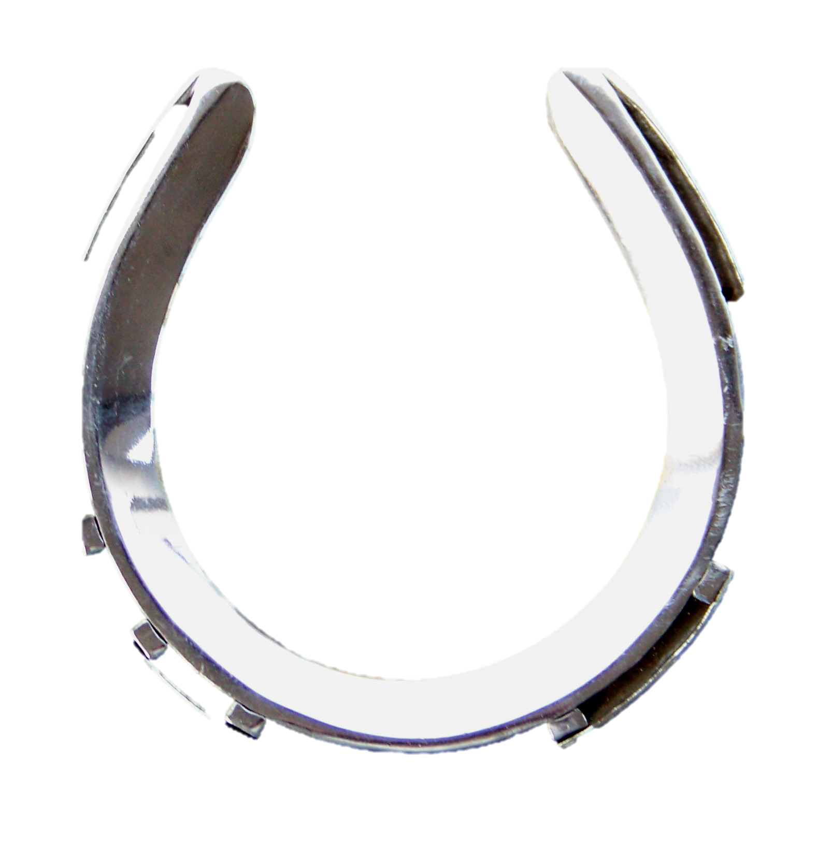

***Join Free Today and begin getting all the Hot News!!!***

Name_______________________________________Age_____DOB______________

Address_____________________________________ Phone______________________

City__________________State___Zip_________email__________________________

USDF member__________________ GMO member___________________

Level(s) you are currently competing________ Distance you typically travel to participate_________

I am interested in (circle): clinics / camps / NAJYRC / sponsorships / scholarships/fundraising/volunteering /giving back

Send this form to:

RYDR, c/o Jodi McMaster, 27100 SW Xanthus CT, Sherwood, Oregon 97140; jodimcmaster@yahoo.com

***RYDR is a Region 6 program for the youth dressage rider offering:***

* *New Regional programs.*
* *Regional & national pipeline talent-scouting.*
* *Recognition and education programs.*
* *Information on sponsorships, scholarships and donations.*
* *Qualify or support team competing at the National Level.*
* *Network with professionals, youth and parents.*
* *Clinics, camps and other opportunities*

**Region 6**

**Youth Dressage Program 2014**